**Assessment Cover Page**

|  |  |
| --- | --- |
| *Student Full Name* | Daniela Mariano Barreto |
| *Student Number* | 2023278 |
| *Module Title* | Strategic Thinking |
| *Assessment Title* | CA 3 Final Submission |
| *Assessment Due Date* | 11th May 2024 |
| *Date of Submission* | 10th May 2024 |

**Declaration**

By submitting this assessment, I confirm that I have read the CCT policy on academic misconduct and understand the implications of submitting work that is not my own or does not appropriately reference material taken from a third party or other source.

I declare it to be my own work and that all material from third parties has been appropriately referenced.

I further confirm that this work has not previously been submitted for assessment by myself or someone else in CCT College Dublin or any other higher education institution.

**Applied machine learning models to estimate material to adsorb CO2**

by

*Daniela Mariano Barreto*

*Higher Diploma in Science in Data Analytics for Business Strategic Thinking*

*James Garza*

*CCT College*

*Dublin, Ireland*

Abstract

The increase in carbon dioxide (CO2) in the atmosphere started decades ago, and this problem persists today, potentially explaining climate change due to the greenhouse effect. In parallel, many industries are seriously considering developing sustainable business practices to cater to environmentally aware customers. Therefore, seizing upon this potential business opportunity, this project aimed to identify the materials most used in CO2 adsorption, as divulged in scientific articles, and to assess machine learning models capable of predicting a suitable material given a concentration of this gas. Subsequently, Decision Tree Classifier, Gradient Boosting Classifier, and Random Forest Classifier were implemented, with SMOTE addressing class imbalance, random search and stratified K-Fold cross-validation to optimize hyperparameters, validation, and mitigation of bias risk. The findings suggest that these models exhibited robust performance using these techniques. Moreover, the emphasis on recall (0.87) and precision (0.89) metrics surpassing predefined success criteria signifies a satisfactory level of accuracy in identifying true positive instances. Importantly, the 'CO2_uptake' significantly influenced predictions, highlighting the relevance of this feature in choosing the appropriated material in adsorption process. Nevertheless, there remains a need for further refinement and enhancement, particularly in augmenting minority class records to bolster the reliability of the models.

**Key-words:** Decision Tree, Gradient Boosting, Random Forest, CRISP-DM, SHAP, Shapash.

GitHub link:

<https://github.com/CCT-Dublin/capstone-project-sep-2023-ft-DanielaBarreto2023278.git>

Contents

**Introduction** 1

**Business description** 2

*Hypothesis* 2

*General goal* 2

*Scope* 3

*Success criteria* 3

**Technologies** 4

*Libraries* 4

*Models and machine learning algorithms* 4

*Hyperparameters tuning and cross validation* 4

**Challenges** 2

**Cross Industry Standard Process - Data Mining (CRISP-DM)** 2

Business understanding 4

Data understanding 4

Data preparation 8

Models screening 9

Models implementation 11

Models explainability 18

Models deployment 21

**Comparison** 25

**Findings** 26

**Conclusions** 26

**Future recommendations** 26

**Ethical considerations** 27

**Poster** 27

**Appendices** 30

**References** 32

**Supplementary information** 34

**References for supplementary information** 40

# **Introduction**

Concern about the increase in carbon dioxide (CO2) in the atmosphere began decades ago. Still, this problem continues nowadays with unsatisfactory predictions for 2040, in which an increase of approximately 70% and 25% is estimated to produce electricity and coal-based, respectively (Huetteman, Bowman and Slater-Thompson, 2016, p.81; Ren and Liu, 2023, p.1).

Studies show that CO2 emissions have caused enormous global damage due to the greenhouse effect, a potential explanation for climate change. These changes probably cause a decrease in biodiversity and harm to human lives due to tsunamis and earthquakes, for example; consequently, a drastic decrease in ecosystem productivity and economic disparities (Daneshvar et al., 2022, p.1; Ren and Liu, 2023, p.1).

Considering all, we see why mitigating the removal of CO2 has been the focus of several institutions, and the increase in the development of technologies and products is the central reflection of these concerns and actions that have increasingly gained momentum. (Ren and Liu, 2023, p.1). Asif et al. (2018, p.4) and Daneshvar et al. (2022, p.6) have shown the general panorama of all techniques that we have so far (Figure 1.)

**Figure 1:** Techniques for CO2 capture.

This capstone project proposed to focus on the adsorption technique, considering the multitude of options available within each type of technology. This promising method has gained notable attention due to its low operational cost, lower energy demand, ease of handling, and general reliability (Daneshvar et al., 2022, p.4).

In light of the advancements in technologies for CO2 capture, was proposed the implementation of machine learning (ML) models to determine the most suitable materials for adsorbing a desired amount of CO2 for a company. Each material possesses its own peculiarities, necessitating specific action plans that can subsequently be refined to lower production costs and enhance economic feasibility.

# **Business description**

In today's world, many industries are seriously considering developing sustainable business practices in response to the escalating consequences of increased CO2 emissions. Additionally, consumers increasingly favour companies with a 'green' stamp of approval.

In light of this, it is considered a fictitious company specializing in services and materials for CO2 capture and intends to modernize its systems by implementing machine learning models. By analysing data from academic articles, the ML model aims to identify materials most effective for CO2 adsorption, tailored to the specific needs of each sector. This approach could potentially personalize solutions, optimizing the efficiency of CO2 capture in various industries. It could also make significant contributions to environmental sustainability.

## *Hypothesis*

The question raised for this project is whether it will be possible to predict the most suitable material, considering a given CO2 concentration that needs to be captured.

**H0:** There is no significant difference in the CO2 adsorption capacity among the materials tested.

**H1:** There is a significant difference in the CO2 adsorption capacity among the materials tested.

## *General goal*

Principal objective:

The main objective of this project is to assess the performance of various machine learning models to find the best ones capable of identifying the most suitable material for capturing CO2, considering a predetermined amount of the gas. Since each industry emits different concentrations of CO2, they may be interested in implementing certain materials to adsorb this pollutant. Thus, the model aims to estimate which material would best suit the concentration of CO2 needed for adsorption by the industry.

Secondary objectives:

* Identify the principal materials used in the adsorption technique.
* Select and collect data from scientific articles.
* Use the Exploratory Data Analysis (EDA) to understand the data.
* Apply machine learning models to choose three with a high metric score.
* Implement the chosen ML models to predict a material given a specific amount of CO2.

## *Scope*

This project aimed to assess several machine learning models to estimate which materials are suitable for adsorbing a certain concentration of CO2. Several articles were analysed, and the records that met the minimum criteria were compiled into the dataset, which was firstly analysed using descriptive and inferential statistics.

Subsequently, three machine learning models— Decision Tree Classifier (CART), Gradient Boosting Classifier (GBM), and Random Forest Classifier (RF)—were implemented for the core analysis. To address challenges like class imbalance, SMOTE was used. Random search and stratified K-Fold Cross-Validation were employed to adjust hyperparameters, validate the models, evaluate them, and mitigate the risk of bias.

The project's scope was carefully defined, emphasizing the exclusive use of data derived from adsorption techniques within the past fifteen years. Moreover, a selection criterion was applied to source academic papers from reputable journals, ensuring data credibility. To minimize the interference of various factors and guarantee the most impartial results possible, the temperature and pressure conditions were standardized to 25°C and 1 bar.

## *Success criteria*

The success criteria involve finding models that perform well, achieving at least 0.80 for both recall and precision. This is crucial for the project since the goal is to accurately predict materials for CO2 adsorption, making it important to prioritize true positive instances. Recall is valuable for identifying all positive samples, thereby avoiding false negatives, while precision helps limit the number of false positives. Additionally, the F1-score represents a trade-off between these two metrics (Müller and Guido, 2017, pp. 282-283).

# **Technologies**

## *Libraries*

The libraries used are:

* Pandas
* NumPy
* Matplotlib
* Seaborn
* SciPy
* Scikit-learn
* Yellobrick
* imbalanced-learn
* SHAP
* shapash

## *Models and machine learning algorithms*

I used seven models to select the best three models used in this project. Below are models used:

* Ada Boost Classifier
* Gradient Boosting Classifier
* Random Forest Classifier
* Decision Tree Classifier
* k-Nearest Neighbors Classifier
* Gaussian Naive Baye
* C-Support Vector Classification

## *Hyperparameters tuning and cross validation*

Stratified K-Fold cross-validation was applied in the project as it is a usual approach when dealing with imbalanced classes, as it preserves the percentage of samples for each class. It partitions the dataset into K folds while ensuring that each fold maintains the same class distribution as the original dataset (Prusty, Patnaik, and Dash, 2022, p.3), helping to mitigate the risk of bias. I also used Random Search, a technique for hyperparameter tuning, with evaluation using cross-validation (Stratified K-Fold) to estimate the model’s performance.

# **Challenges**

Considering that the emission of CO2 is a global problem, government and private institutions are investing in research to find solutions in this field. Consequently, there is an expectation of having a lot of data. However, it was difficult to find articles with comparable experimental conditions. To overcome this challenge, I prioritized data that had at least two primary conditions: data collected at 25°C and 1 bar.

Another challenge was to find data for minority classes (MOFs and Polymers). I addressed this by increasing the data of the majority class (Carbon-based), which usually has more articles. Then, I used oversampling techniques to cope with it.

In the Gradient Boosting model, I encountered a problem when applying Shap because the TreeExplainer function was not accepting a multiclass problem. However, I overcame this by using a different function called KernelExplainer, which deals with all functions.

In Appendix 1 there is the milestones achieved during this project.

# **Cross Industry Standard Process - Data Mining (CRISP-DM)**

CRISP-DM has been used as a project management methodology (Figure 2a) with the breakdown of the phases. The project plan (Figure 2b) is from gathering data to a conclusion, and all stages are interchangeable; the evaluation can generate results that can return to the preprocessing phase, for example.

The action plan will search for data with comparable experimental conditions, such as pressure and temperature. Use Python in Jupyter Notebook to clean, organize the data and create visualizations for an overview (EDA). Perform descriptive and inferential statistics, followed by preprocessing the data if necessary.

Posteriorly, experiment with some ML models to obtain better results using cross-validation and hyperparameters adjustment. Evaluate the model’s performance and return to any previous phases if necessary. At the end, conclude the findings.

The first approach, using CRISP-DM, halted at the Evaluation step, necessitating a return to data collection to improve the project. More detail about the second approach is presented below.

**Figure 2:** a) CRISP-DP scheme. Source: <https://healthdataminer.com/wp-content/uploads/2019/11/800px-CRISP-DM_Process_Diagram.png>. b) Project plan.

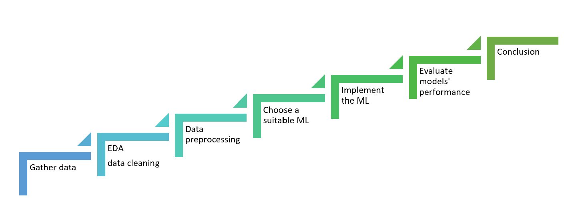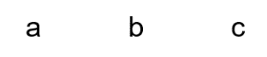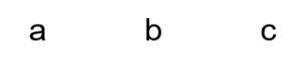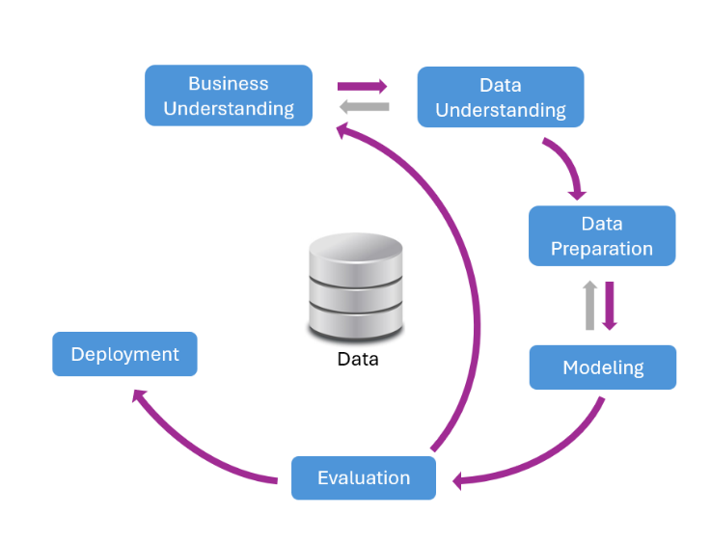

The second approach, using CRISP-DM to enhance this project, is illustrated by the magenta arrows in Figure 2a. There was the necessity of changing the focus of this project to consider CO2 as a dependent variable (along with others) to estimate the material, the target variable, which made more sense and aligned with a potential business problem that might arise.

The increase in the dataset was also highlighted, and it was handled by increasing only the Carbon-based material and using oversampling techniques to improve training in the minority classes, MOFs, and Polymers, as it was not possible to find data for these classes within a limited time.

In the previous phase (CA2), models were chosen by comparing their definitions to the project problem. However, in this phase, an empirical approach was used, screening seven models. Most are based on Gradient Boosting's satisfactory performance, derived from tree-based models' intrinsic traits like robustness and minimal preprocessing needs, while also offering feature importance for decision evaluation (Müller and Guido, 2017, pp. 77, 104).

## Business understanding

The focus on sustainability has led industries to request technologies to capture CO2 from their emissions. This study aims to estimate which material should be suitable in relation to a given concentration of CO2 that the industry wishes to adsorb. This is important to provide information to create a specific plan that meets the sector's needs, avoiding unnecessary expenses.

## Data understanding

*Data source*

Data were gathered from an article that compiled hundreds of sources, focusing on three extensively studied materials: carbon-based materials, metal-organic frameworks (MOFs), and polymers (Dziejarski et al., 2023, pp. 3, 20, 36, 41). However, during the previous phase of this project, the need for additional data arose. While I found more records related to carbon-based materials (Yuan et al., 2021, p.11927), there were no comparable findings for the other materials. This lack of comparable findings is consistent with Dziejarski et al. (2023, p.3), which indicates that most of the research is focused on carbon-based materials. All the data used are presented in the Supplementary Information section in Table S1, followed by references to the sources of each record.

*Data description*

The dataset is composed of 11 features, and 92 records with 3 classes of material used in the CO2 adsorption (carbon-based, metal-organic frameworks (MOFs), and microporous polymers). Features description in table 1.

**Table 1:** Data dictionary.

*Exploratory data analysis (EDA)*

For this analysis, I focused on these features: 'Material', 'BET surface area_m2/g' (SA), 'Total pore volume_cm3/g' (TPV), and 'CO2 uptake_mmol/g_25°C' (CO2_uptake), because they are common to all types of materials and might be related to the CO2 adsorption.

Due to the presence of missing values in two features (SA and TPV), it was necessary to impute them. But first, it was essential to evaluate the descriptive statistics, which revealed that the data was skewed, indicating that the data in these two columns do not follow a normal distribution. This information was crucial for selecting the appropriate method to impute the missing values, such as mean, median, or interpolation. In this case, in which the features were skewed and had outliers, imputation with the median tends to be a reasonable approach, as interpolation is indicated when the data change over time, which is not the case here. Moreover, the median is generally more robust to outliers.

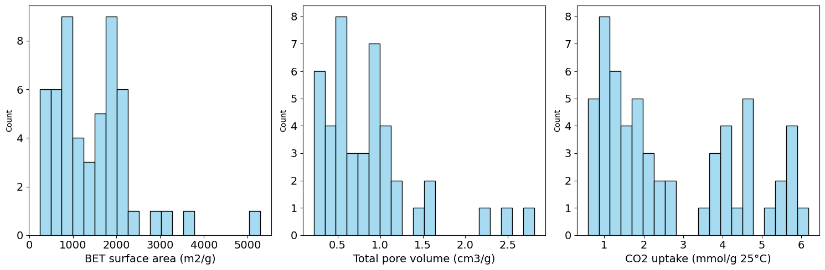

a

e

c

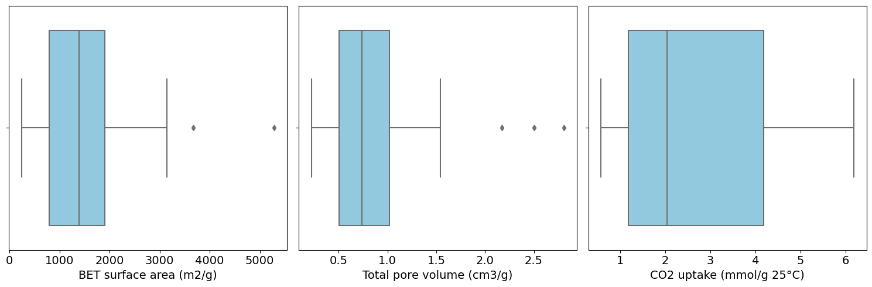

d

b

f

**Figure 3:** Histogram and boxplot before data imputation. 'BET surface area_m2/g' (a and b), 'Total pore volume_cm3/g' (c and d), ‘CO2 uptake_mmol/g_25°C’ (e and f).

*Data Cleaning*

The dataset had no duplicates, but 6.5% of the values were outliers. Therefore, since it was a significant amount, I decided not to remove them because it could compromise the data integrity, especially considering the presence of imbalanced classes that might affect the model's performance. To address this issue, I will seek a robust machine learning method to handle it.

*Descriptive Statistics*

Summary statistics parameters showed that data is skewed and is reasonable sparse due to the encode with zero the carbon-based material. The minimum and maximum values presented a considerable variance, and each feature's scale is very different; thus, it will be necessary to scale the data.

Figures 4 presented the pair plot and heatmap. The results showed a moderately strong positive correlation between SA and TPV (0.70); thus, there was a tendency to increase area at the same time as increasing volume and vice versa. However, when comparing CO2_uptake with SA (0.23), the correlation was weak if compared with Area and Volume. In addition, practically, there was no correlation between CO2_uptake and TPV (0.085), meaning little or no linear correlation that can be negligible.

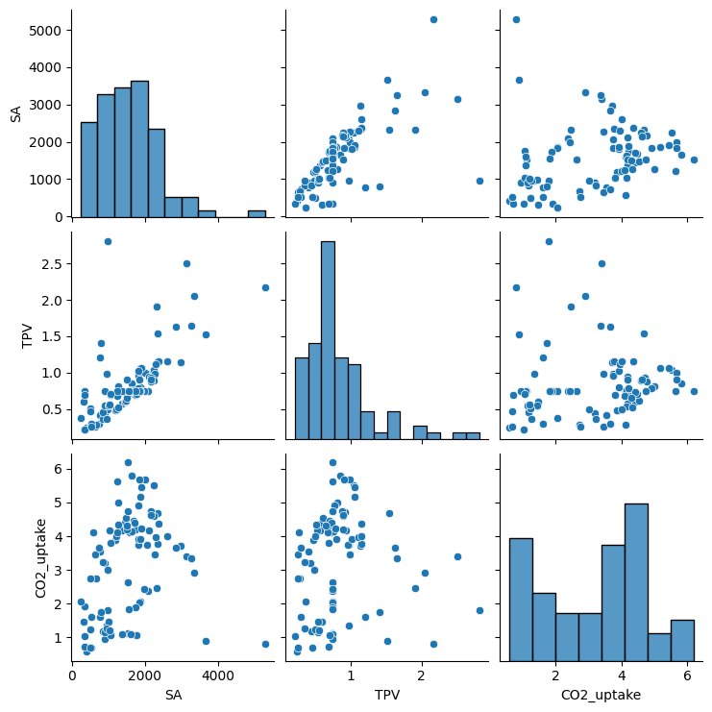

a

b

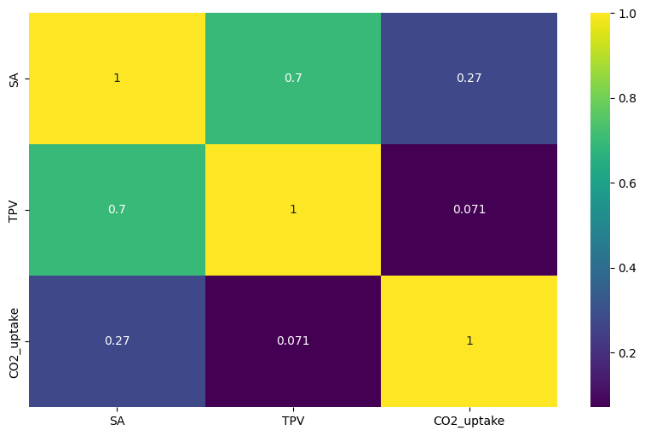

**Figure 4:** a) Pair plot, and b) heatmap of features correlation. SA: BET surface area (m2/g). TPV: Total pore volume (cm3/g). CO2_uptake: CO2 uptake (mmol/g 25°C).

*Inferential Statistics*

Considering that the dataset does not follow a normal distribution, I opted to apply the Kruskal-Wallis test because it tends to be appropriate when handling a non-normal distribution and small sample size, as it does not make assumptions about the data's normality (Devore, 2012, p.645).

With a 95% confidence level, I found that there is a significant difference in the CO2 adsorption capacity among the materials tested. Therefore, the material that can adsorb more CO2 in this case is Carbon-based, followed by MOFs and then Polymers (see Figure 5).

This result can provide important information that can be used to tailor the best material to an industry's needs. For instance, if a company needs to adsorb 4 mmol/g of CO2 at 25°C and 1 bar, the model should directly suggest a 'Carbon-based' material, which could avoid expending time and resources on other materials that may not meet their requirements. Employing a machine learning model is expected to yield a more refined selection process.

**Figure 5:** CO2 uptake in three different materials under a pressure condition of 1 bar.

## Data preparation

*Preprocessing*

Data scaling is a common preprocessing step for many machine learning models because there is a considerable variation between features that can contribute to inaccurate predictions since features with larger scales may dominate the calculations (Müller and Guido, 2017, p.138). In this project, I employed the RobustScaler function, which is more suitable in the presence of outliers. This is essential for many ML models (scikit-learn, n.d.), especially considering there are outliers in this dataset.

Considering that the data have significantly imbalanced classes, I handled this challenging using the Synthetic Minority Over-sampling Technique (SMOTE), that potentially results in better generalization compared to traditional methods (Chawla, 2002; Chawla, 2010, p. 881; imbalanced-learn.org, n.d.) (Figure 6).

Additionally, I applied one-hot encoding to avoid attributing undue weight to categories, ensuring that all materials have equal importance.

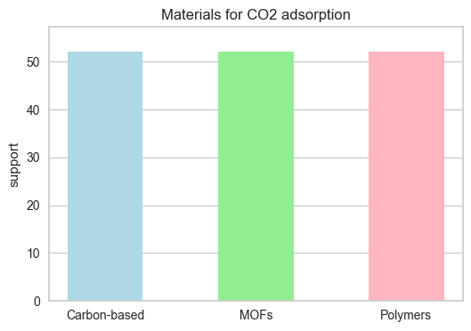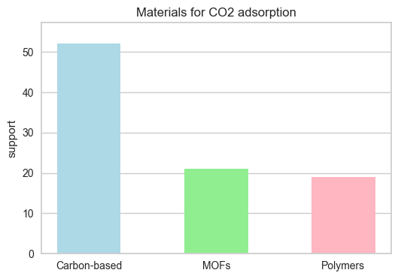

a

b

**Figure 6:** a) Sample without SMOTE. b) Sample with SMOTE.

## Models screening

In this section, I experimented with seven ML models to find the best three to use in this project to predict the most suitable material to adsorb CO2, given the concentration of this gas.

The chosen metric is F1-score when the data is imbalanced and accuracy when the data is balanced with SMOTE because accuracy might not be appropriate when the data is imbalanced; the F1-score metric tends to be more reliable in this case as it is a trade-off between precision and recall in the rare class (Chawla, 2010, p. 876-878). This differentiation is essential to reduce bias when giving more weight to one class over the other.

I also tested n_splits equal to 5 and 3 using Stratified K-Fold, as this approach is usually recommended when dealing with imbalanced classes. It partitions the dataset into k folds while ensuring that each fold maintains the same class distribution as the original dataset (Prusty, Patnaik, and Dash, 2022, p.3), preserving the percentage of samples for each class, which is essential when dealing with imbalanced datasets.

*Results*

Considering that in this project I am interested in prioritizing true positive results, I focused on identify models that correctly identify positive instances, because of this I evaluated metrics such as recall, precision, and F1-score. Looking at the charts (Figure 7), we see that all tested conditions performed well, with scores above 0.86. Also, the top models performed similarly across these conditions. However, the condition without SMOTE and n_splits equal to 3 notably improved the precision, recall, and F1-score in the two minority material classes, MOFs (class 1) and Polymers (class 2). Given the significance of accurate classification for these minority classes in comparison to the majority class, Carbon-based (class 0), I will opt for these conditions to implement the three best-performing models, namely: Decision Tree Classifier (CART), Gradient Boosting Classifier (GBM), and Random Forest Classifier (RF) equally to Ada Boost Classifier (AB).

**Figure 7:** Machine learning model screening results: a) Stratified K-Fold with n_splits=5 and b) Stratified K-Fold with n_splits=3.

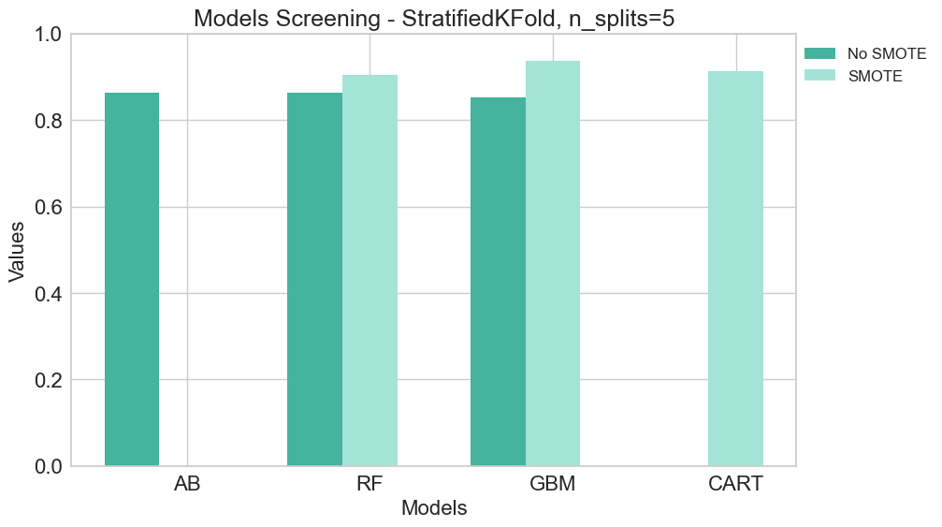

a

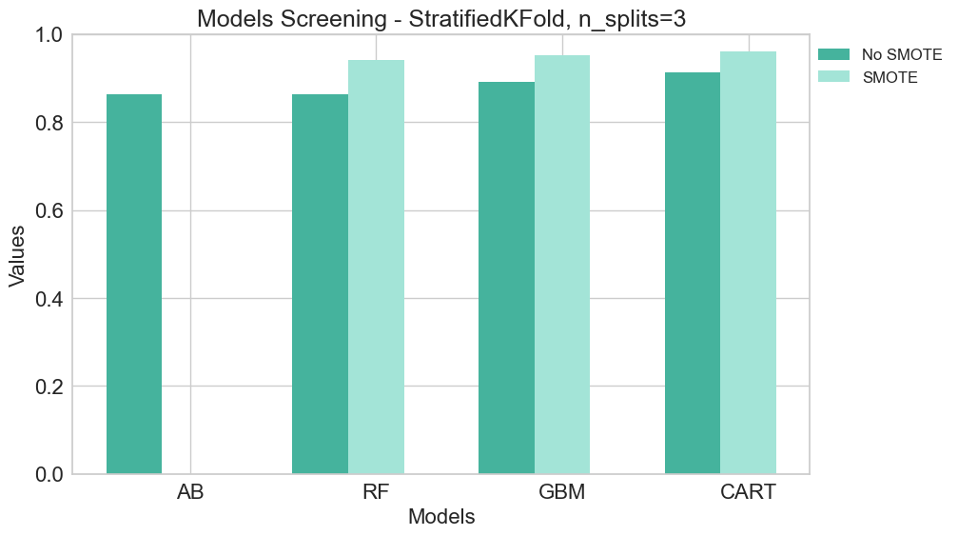

b

In the confusion matrix with SMOTE and without SMOTE using n_splits = 3 (Figure 8), the misclassification for the minority classes (MOFs and Polymers) was only one instance for each class, a promising result.

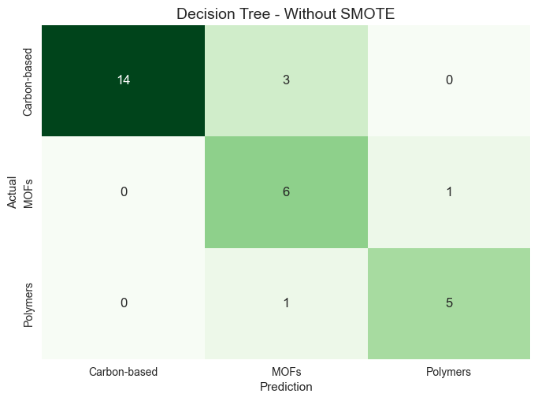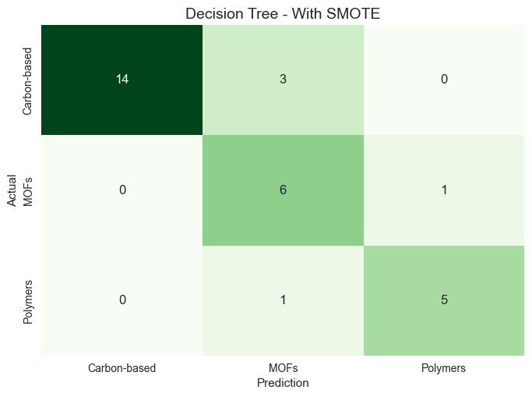

**Figure 8:** The confusion matrix of the model’s screening is on the left without SMOTE use and on the right with SMOTE use, both are in the test set.

## Models implementation

The models selected in the previous section (CART, GBM, and RF) were implemented using Stratified K-Fold (n_splits=3) to maintain class distribution in each fold, ensuring robust validation without data leakage, both with and without SMOTE. Employing Random Search facilitated hyperparameter optimization for each model, and their performance was evaluated using metrics such as accuracy, precision, recall, and F1-score. Additionally, I utilized a pipeline to set up the three models simultaneously, integrating both Stratified K-Fold and Random Search.

This project focuses on achieving high values for recall, as it is crucial to identify all positive samples, thus avoiding false negatives, while precision serves to limit the number of false positives, and the F1-score represents a trade-off between these two metrics (Müller and Guido, 2017, pp. 282-283).

*Results*

In the experimentation without SMOTE, high values were found for all metrics in both the train and test sets (Figure 9). However, a significant difference exists between these sets in both Decision Tree and Gradient Boosting models, indicating that they may be slightly overfitting. The Random Forest model appears to generalize better to the test set in comparison with the other models. Additionally, the recall value was greater than the others, meaning that the Random Forest model is capable of correctly identifying true positive samples 87% of the time. These results prompted experimentation using SMOTE on the training set in an attempt to improve the models' ability to generalize.

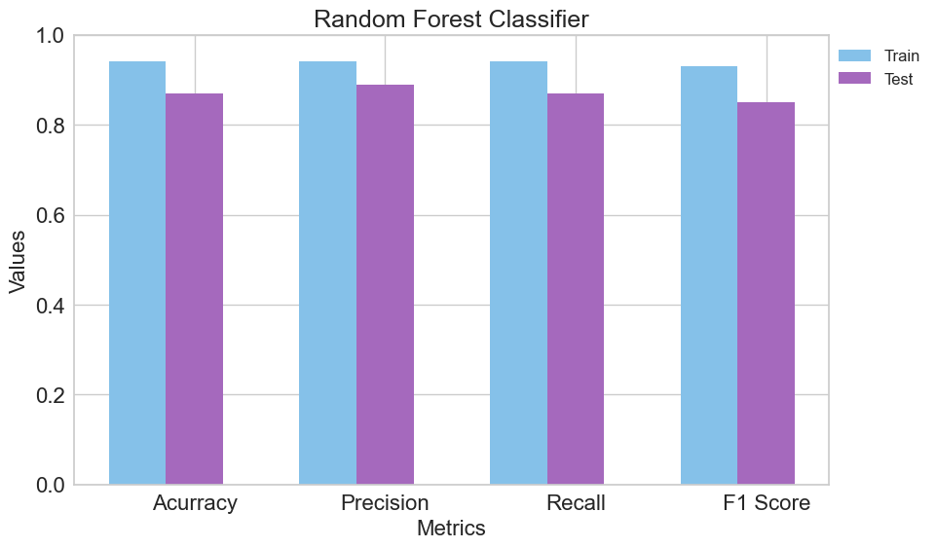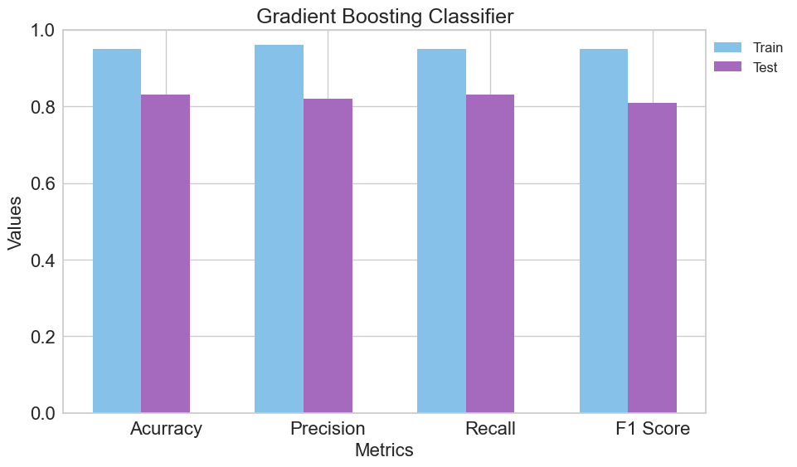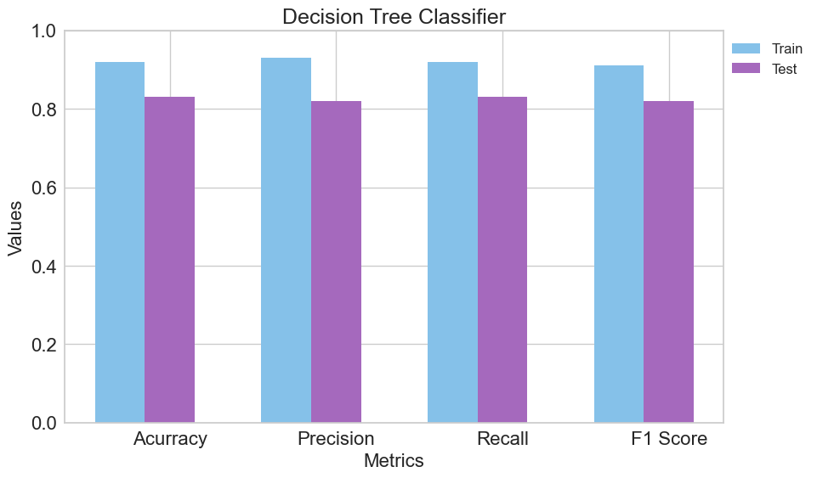

a

b

**Figure 9:** Models implementation without SMOTE: a) Decision Tree, b) Gradient Boosting, and c) Random Forest.

c

The use of SMOTE resulted in the improvement of the three models (Figure 10), which exhibited good performance in both the training and test sets, suggesting that there is not significant overfitting with any of these models. This indicates that the models can generalize well to unseen data. Furthermore, focusing on the recall metric—highlighting the accuracy in identifying actual positive samples—all models demonstrated similar results (ranging from 0.80 to 0.83) in the training set and 0.87 in the test set, reaffirming their strong ability to generalize. Moreover, Gradient Boosting exhibited greater consistency across other metrics, with negligible disparities observed between the datasets.

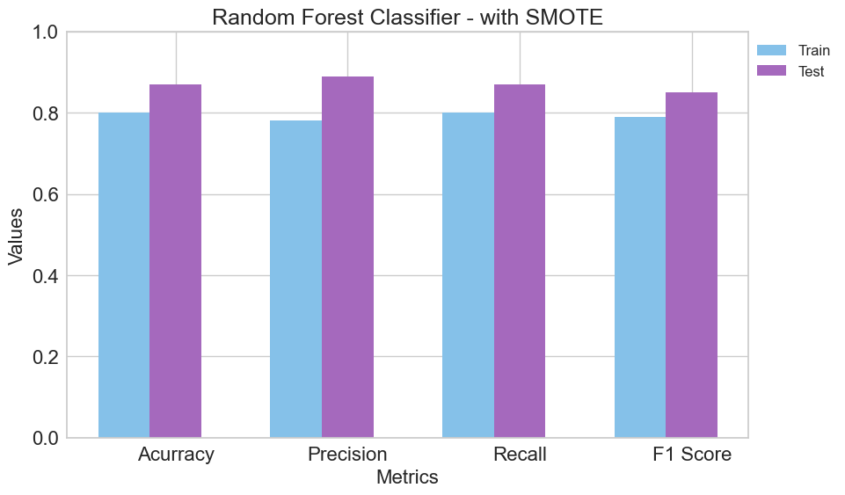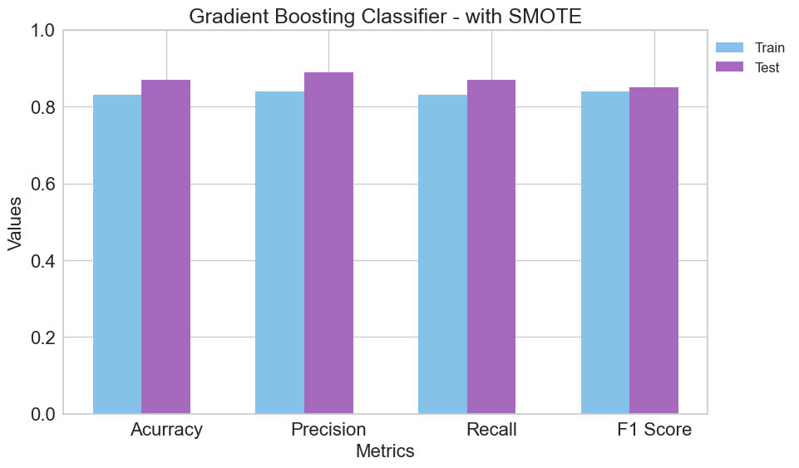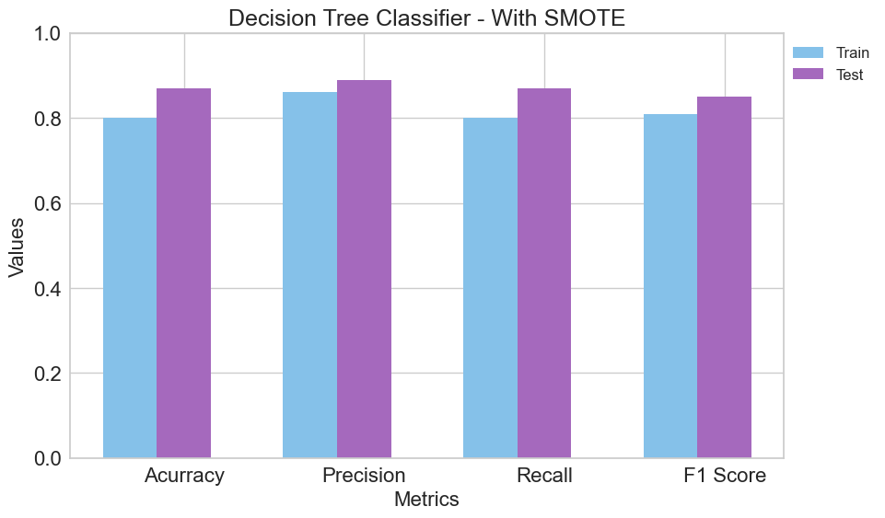

a

b

c

**Figure 10:** Models implementation with SMOTE: a) Decision Tree, b) Gradient Boosting, and c) Random Forest.

Considering the metrics of the three models, similar performance was observed in terms of true positive instances (recall) on the test set, with each model achieving a recall of 0.87. This indicates that 87% of the instances were correctly identified as positive by each model. Similarly, precision yielded consistent results, with 89% of the samples predicted as positive actually being positive.

The confusion matrix (Figure 11) of the training set resulted in correctly predicting true positives in all classes for all models, which generally indicates that the model is performing well when the dataset is balanced.

Upon further examination of the confusion matrix, it is evident that the test set excelled in identifying the majority class (Carbon-based). However, despite the enhancements brought about by SMOTE, both MOFs and Polymers still encounter challenges in minimizing false positives. This emphasizes the necessity of improving precision to address this issue effectively, although the precision score remains high (0.89) for the test set and all models. On a positive note, the Decision Tree model exhibited commendable performance in identifying the minority classes, with just one misclassification observed.

**Figure 11:** Confusion matrix with SMOTE: a) Decision Tree, b) Gradient Boosting, and c) Random Forest.

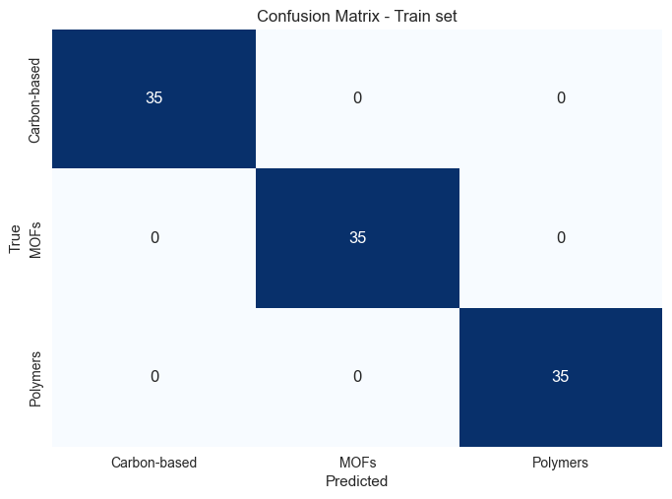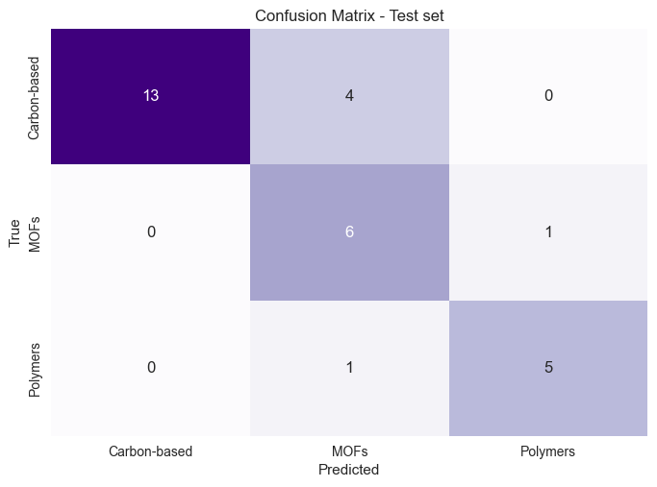

a



b

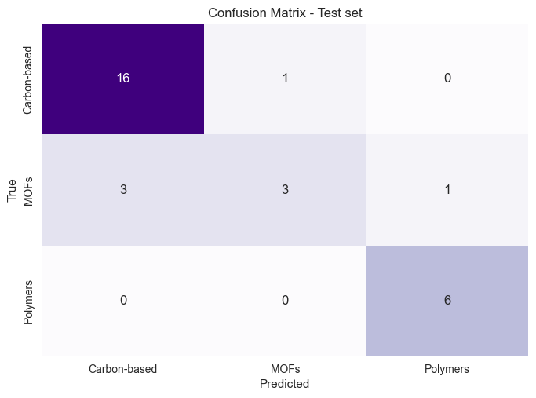

c

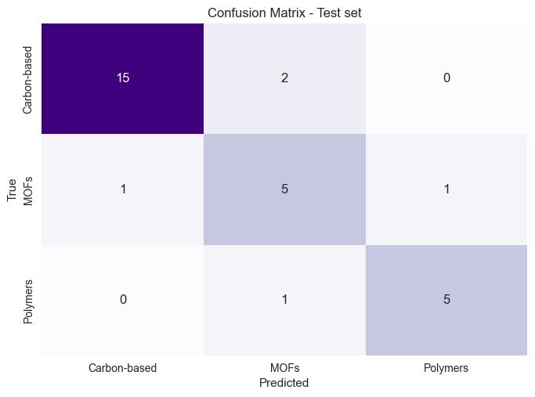

In Figure 12, the feature importance for the three models is presented. For all models, CO2_uptake emerges as the most important feature, followed by SA and TPV. This suggests that the models' predictions were primarily influenced by CO2_uptake and less influenced by TPV. Considering the moderately strong positive correlation between SA and TPV, as observed in the Descriptive Statistics section, removing the TPV feature could potentially improve predictions. However, since the model is already performing well, removing a feature may increase the risk of overfitting due to the simplification of the models. Therefore, I have decided not to remove it.

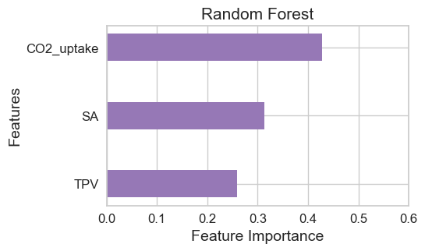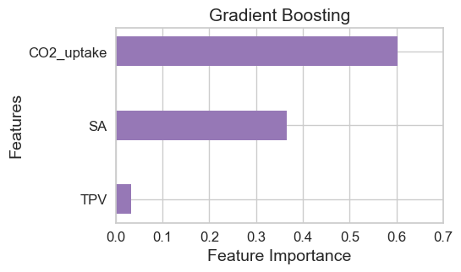

c

b

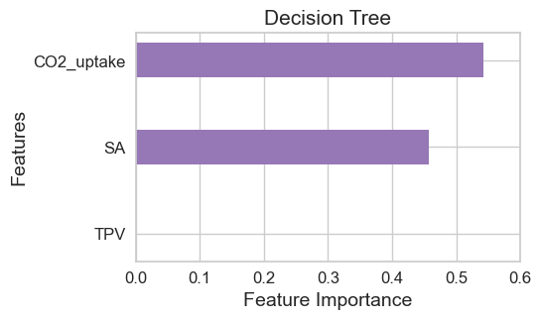

a

**Figure 12:** Feature Importance: a) Decision Tree, b) Gradient Boosting, and c) Random Forest.

## Models explainability

SHAP (SHapley Additive exPlanations) is a game-theoretic theoretical approach designed to explain the outputs of any machine learning model (shap-lrjball.readthedocs.io, 2024). These explanations are essential to ensure that models are not only accurate but also interpretable. Within the SHAP toolkit, the TreeExplainer stands out as a specific method developed to explain tree-based models (Lundberg et al., 2020, p.56).

In this project, I used the Shap method to try to explain and interpret the models output. Since all the models I am using are tree-based (Decision Tree, Random Forest, and Gradient Boosting), I used a specific method to deal with these models, which is the TreeExplainer. However, when applying it to Gradient Boosting, I found that this method is not appropriate for multiclass problems, only for binary ones. Thus, I used the KernelExplainer, another Shap method that can handle any function (shap-lrjball.readthedocs.io, 2024a).

*Results*

Figure 13 shows the summary plot for each model. We observe that the bar charts are similar to the Feature Importance plots (Figure 12); however, here we can discern the magnitude of the impact of each feature on the predicted probability for the corresponding class. Across all models, for instance, the 'CO2_uptake' feature influences the prediction of class 0 more significantly than the other classes, while the 'SA' feature influences the prediction of class 2. Additionally, 'TPV' lacks influence in the Decision Tree but exhibits a similar impact in Gradient Boosting for predicting classes 0 and 1. In Random Forest, it holds more influence in predicting class 1.

A force plot provides an individualized interpretation of the models’ prediction for a single instance, helping to understand the prediction based on each characteristic considered for the decision (Figure 14). For example, if we consider instance 2, for the Gradient Boosting, we can see that feature 2 (CO2_uptake) has a predominant influence in predicting 'Material_0' for this instance. The same happened with the Decision Tree model. In both models, the f(x) was equal to 1, meaning a very strong prediction for instance 2. However, for the Random Forest, the f(x) was equal to 0.76, which is relatively strong but leaves more room for doubt than the other models. This result is likely attributable to the influence of an additional feature (feature 0 = 'SA').

Hence, these findings validate the predominant role of ‘CO2_uptake’ across all implemented models. This discovery holds promise, as the primary objective of this project is to accurately forecast the most suitable material based on a given CO2 concentration.

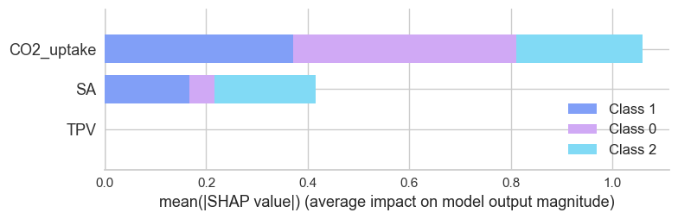

a

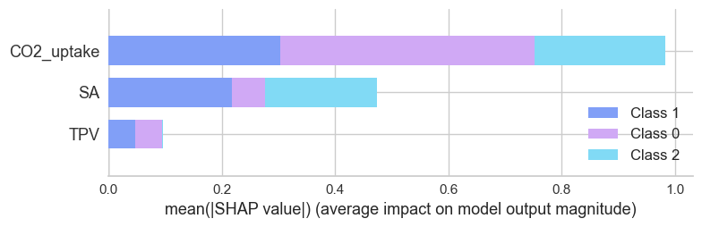

b

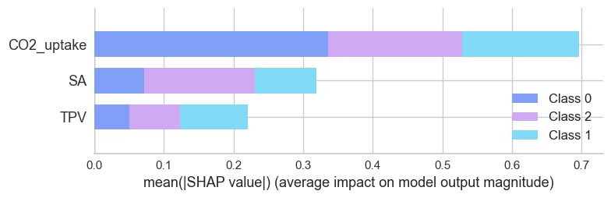

c

**Figure 13:** SHAP Summary - Class Influence: a) Decision Tree, b) Gradient Boosting, and c) Random Forest.

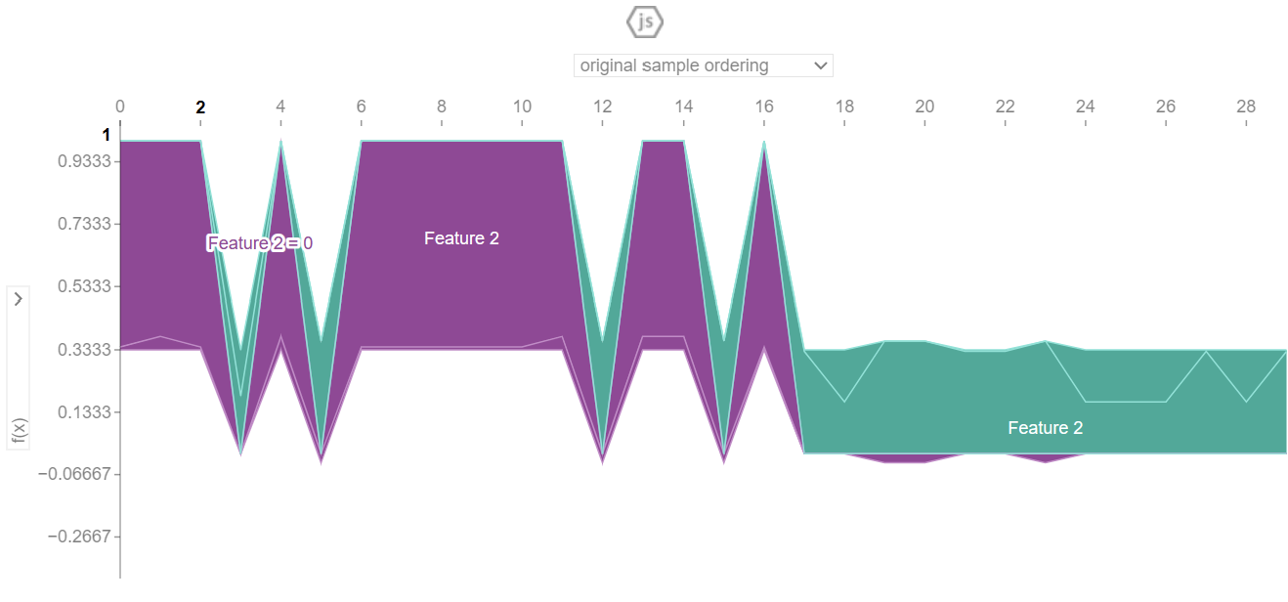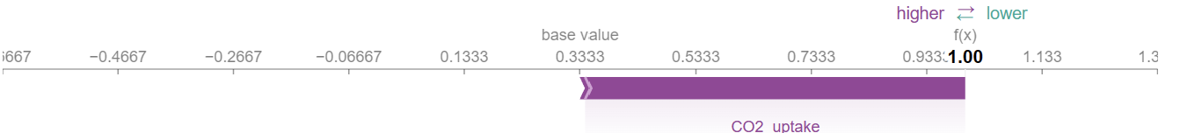

a

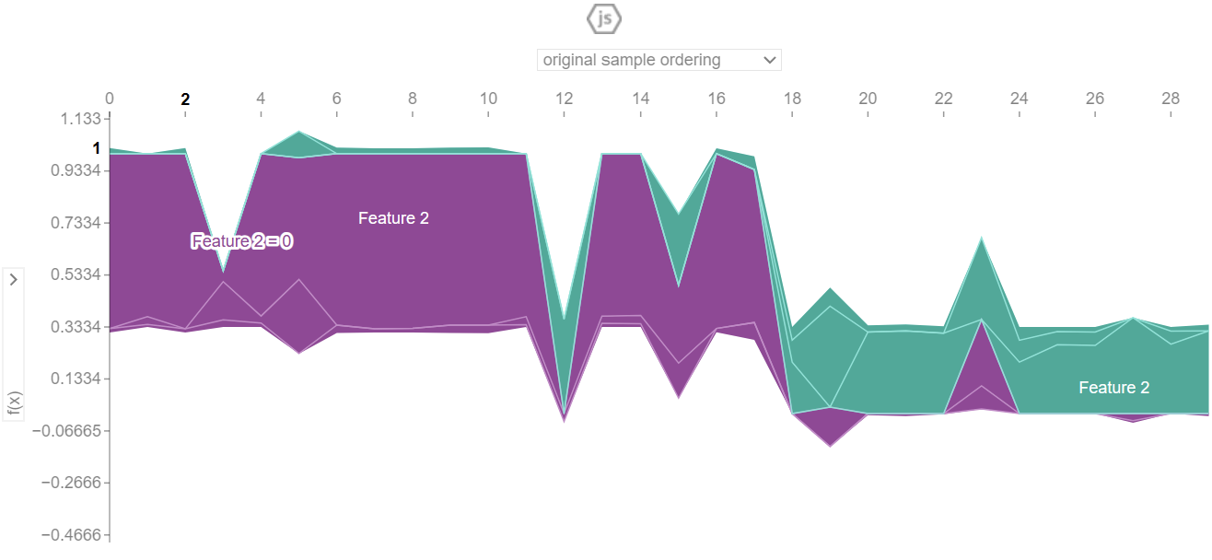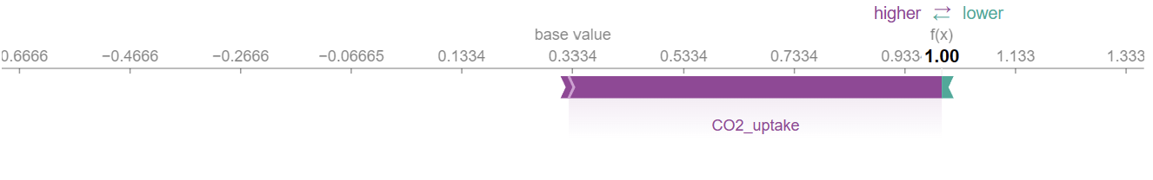

b

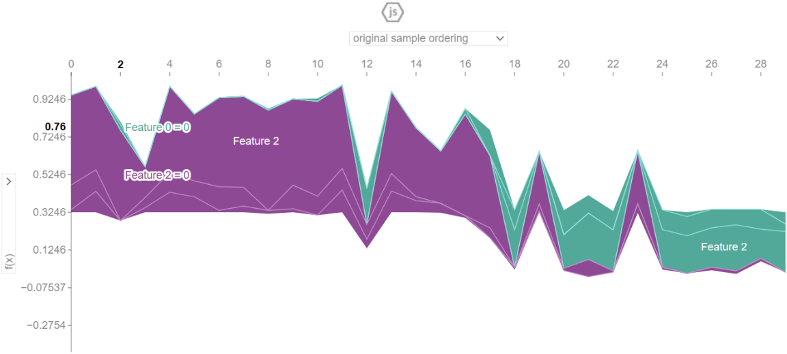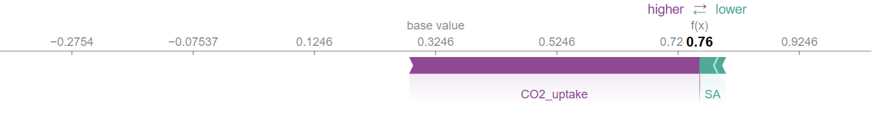

c

**Figure 14:** Instance prediction breakdown for instance 2 (selected): a) Decision Tree, b) Gradient Boosting, and c) Random Forest.

## Models deployment

*Prediction*

In this stage, I used the scaled data to make predictions using the models trained previously: Decision Tree, Gradient Boosting, and Random Forest. I used the indices of the X variables ('SA', 'TPV', 'CO2_uptake') to find the corresponding materials in the target variable ('Material_0', 'Material_1', and 'Material_2').

I used index '0' to facilitate the comparison of predictability between all the models. In summary, despite the data being scaled, the models predicted the material best suited for adsorbing approximately 4 mmol/g of CO2 at 25°C and 1 bar.

*Results*

As we can see in Figure 15, all models performed excellently with scores around 0.94 (accuracy). Furthermore, they consistently predicted the same material when using the same index, which was 'Material_0'. This indicates that the Carbon-based material would be the most suitable for adsorbing 4 mmol/g of CO2 at 25°C and 1 bar.

However, the 'predict_proba' results seem to be more meaningful for the Gradient Boosting and Random Forest models because they can show the probability of the predicted class more significantly, rather than just showing a binary prediction without probability estimation for the predicted class as observed with the Decision Tree model. Consequently, the probabilistic outputs from Gradient Boosting and Random Forest models contribute to a more comprehensive understanding of the prediction process, enhancing the models' interpretability and reliability.

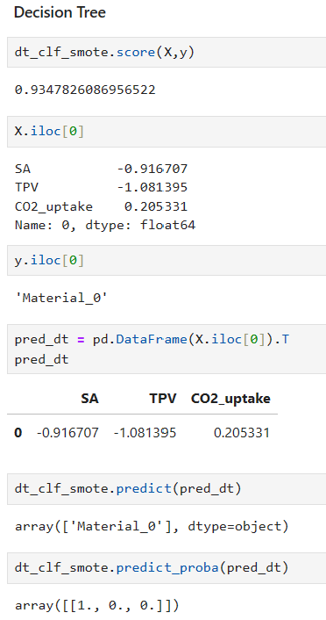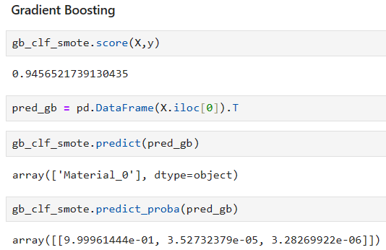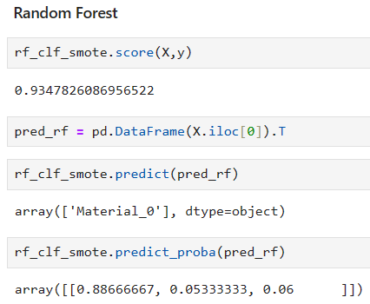

**Figure 15:** Comparative predictions of Decision Tree, Gradient Boosting, and Random Forest models using the same index.

*Shapash*

Shapash is based on Shap and Lime with the aim of promoting model interpretability in a simplified and straightforward way (shapash.readthedocs.io, n.d.). Using this resource, I identified which features contribute to the predicted class. Additionally, I compared two indexes to understand how the features contributed to the prediction and to determine the probability of the output occurring based on the input.

To maintain a fair comparison between the three models, I used the same indexes (20 and 78), with the first one from 'Material_0' and the second one from 'Material_2'. The charts are shown in Figure 16.

*Results*

The Shapash plot resulted in all models predicting the same material ('Material_2') for the two indexes. However, it clearly evidences that only one of the indexes (index 78), has the highest probability of belonging to 'Material_2'. In contrast, the probability of index 20 belonging to 'Material_2' is null or too low. This means that Shapash could identify good predictability for all models. Additionally, similar to the previous predictions, the probabilistic outputs given by the Random Forest model contribute to a more comprehensive understanding of the prediction process made by the model.

Analysing the charts, we can see that the prediction for index 78 was mainly contributed to by the ‘CO2_uptake’ feature for Decision Tree and Gradient Boosting, while the ‘SA’ feature for the Random Forest. This means that CO2 uptake had a significant contribution to those two models’ decisions, which is aligned with what was found in the ‘Models explainability’ topic (Figure 14).

Considering index 20, we see an opposite behaviour in which the ‘CO2_uptake’ contribution is negative in all models’ predictions, followed by an insignificant or negative contribution from ‘SA’ and ‘TPV’.

Therefore, these results confirm the highest contribution of ‘CO2_uptake’ compared to the other features in two of the three models (Decision Tree and Gradient Boosting), which can be a promising result since the aim of this project is to predict the most suitable material given a certain CO2 concentration.

**Figure 16:** Comparative interpretation of models for instances 20 and 78: a) Decision Tree, b) Gradient Boosting, and c) Random Forest.

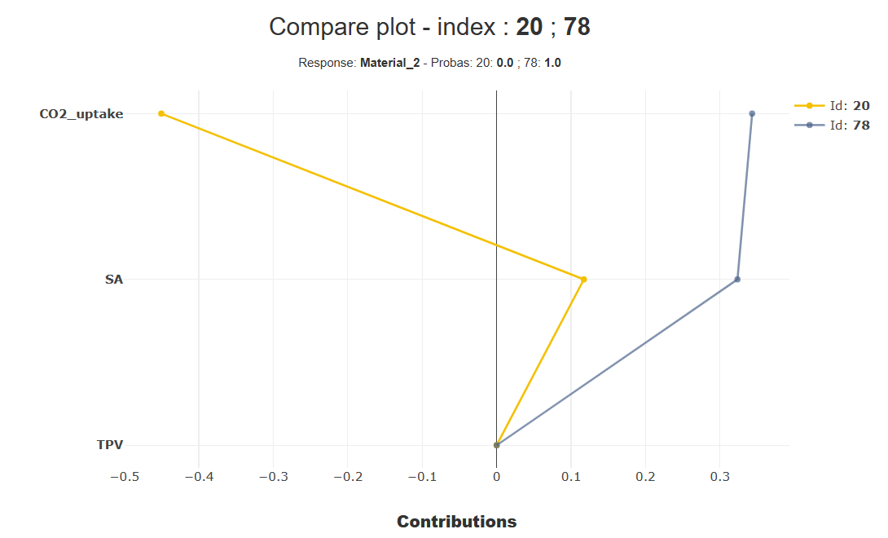

a

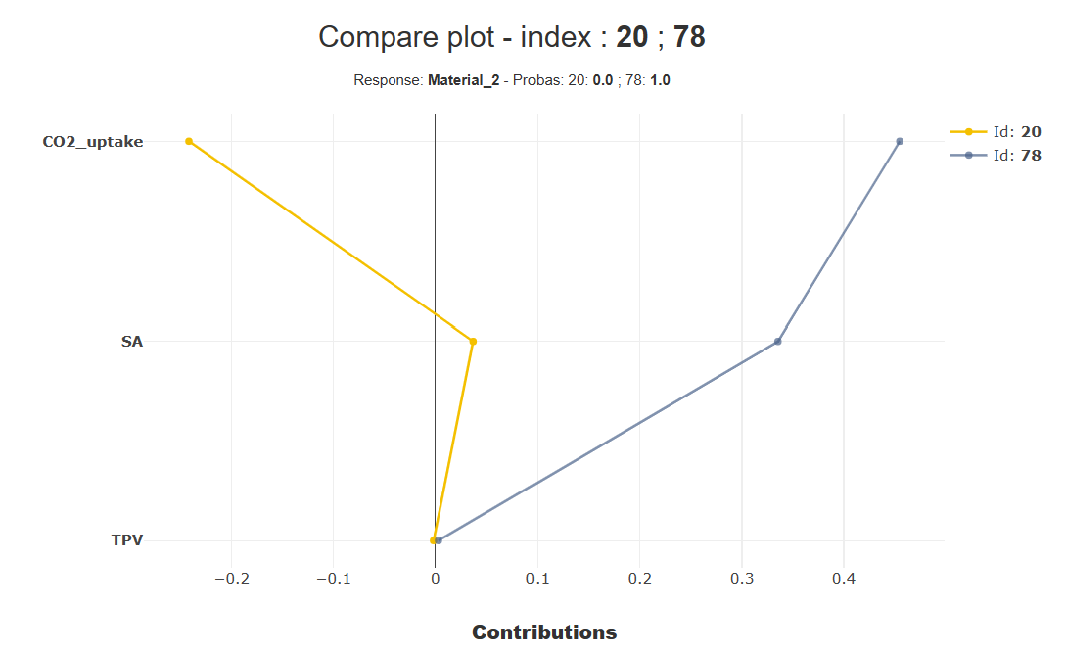

b

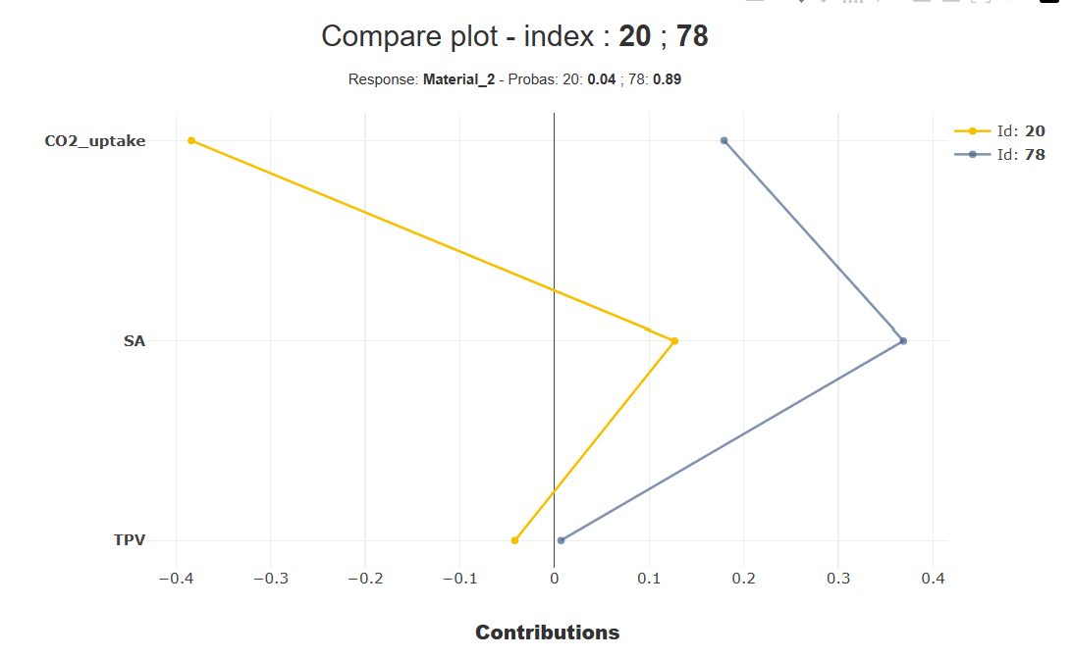

c

# **Comparison**

Exploring the effectiveness of machine learning algorithms—Decision Tree, Gradient Boosting, and Random Forest—it was possible to identify that all of them performed similarly, inclusive of the models' explainability results.

In this project, we observed that the use of SMOTE promoted good performance in both the training and test sets for all models, suggesting a strong ability to generalize, with 0.87 for recall and 0.89 for precision (test set), they correctly indicate the identification of positive instances—the focus of this project.

Although SMOTE had a positive influence on the minority classes (MOFs and Polymers), there were difficulties in predicting true positive instances by Gradient Boosting and Random Forest. However, the Decision Tree exhibited commendable performance in identifying these classes, with just one misclassification observed in each minority class.

For all models, ‘CO2_uptake’ emerges as the most important feature, followed by ‘SA’ and ‘TPV’, inclusive in the results of models explainability (Shap), which is an important fact as the aim of this project is to predict the most suitable material based on a given CO2 concentration.

After testing the predictability of the models to identify the most suitable material to adsorb 4 mmol/g of CO2 using the scaled data, the result was promising for all models because they predicted the same material, which was the correct one, and all of them performed with an accuracy around 0.94.

Additionally, the use of Shapash was very insightful to compare predictions between two instances at the same time, resulting in a significant contribution of the ‘CO2_uptake’ in the Decision Tree and Gradient Boosting predictions.

Essentially, all models implemented in this project demonstrated satisfactory performance, thanks to the utilization of SMOTE, which notably enhanced the prediction accuracy of minority classes. Moreover, the predictions of all models were predominantly influenced by 'CO2_uptake,' revealing a direct correlation between the material used and CO2 concentration.

# **Findings**

* The principal finding was the positive effect of SMOTE in the training set, enabling models to effectively learn data patterns and resulting in well-trained models. This effect was particularly important in the test set (without SMOTE), leading to improved true positive class predictions while reducing false positive instances, with relatively high recall (0.87) and precision (0.89).

* Another significant finding was that the 'CO2_uptake' feature predominantly influenced model predictions, aligning perfectly with the project's objectives.
* The third finding highlighted the surprising achievement of high metrics despite the reduced number of records for the materials MOFs and Polymers. Nevertheless, increasing the records for these classes remains necessary to obtain more reliable models.

# **Conclusions**

In essence, after screening the models, it was possible to select robust models that performed well with this dataset, which was also improved by the usage of SMOTE. Additionally, the Stratified K-Fold cross-validation associated with the Random Search facilitated hyperparameter optimization, contributing to the overall generalization of the models, with the 'CO2_uptake' feature being the most influential in predictions. Upon examining the results, there was an improvement in the prediction of true positive instances while simultaneously reducing false positive predictions. However, there is room for improvement in these metrics, which might involve increasing the records of the minority class, enhancing the reliability of the models.

# **Future recommendations**

I would recommend increasing the number of records, particularly in the minority classes (MOFs and Polymers), to improve the reliability of the results. Additionally, I suggest adding more features, if possible, to increase the complexity of the models, as long as it does not increase the chances of overfitting.

# **Ethical considerations**

This project did not intend to work with data that involves sensitive data, user privacy or potential social impacts; the data was essential from laboratory research. The data was not anonymised because they are from researchers who have done all the research and deserve to be appropriately recognised. In Appendix 2, are presenting the Ethics Form signed.

# **Poster**

# **Appendices**

Appendix 1: Milestones achieved.

Appendix 2:

# **References**

Chawla, N.V. (2010). Data Mining for Imbalanced Datasets: An Overview. In: *Data Mining and Knowledge Discovery Handbook*. [online] pp.875–886. doi:https://doi.org/10.1007/978-0-387-09823-4_45. [Accessed 13 Dec. 2023].

Chawla, N.V., Bowyer, K.W., Hall, L.O. and Kegelmeyer, W.P. (2002). SMOTE: Synthetic Minority Over-sampling Technique. *Journal of Artificial Intelligence Research*, [online] 16(16), pp.321–357. doi:https://doi.org/10.1613/jair.953.

Daneshvar, E., Wicker, R.J., Show, P.-L. and Bhatnagar, A. (2022). Biologically-mediated carbon capture and utilization by microalgae towards sustainable CO2 biofixation and biomass valorization – A review. *Chemical Engineering Journal*, 427, p.130884. doi:https://doi.org/10.1016/j.cej.2021.130884.

Devore, J.L. (2012). *Probability and statistics for engineering and the sciences*. Belmont, Calif.] Brooks/Cole, Cengage Learning.

Dziejarski, B., Serafin, J., Andersson, K. and Krzyżyńska, R. (2023). CO2 capture materials: a review of current trends and future challenges. *Materials Today Sustainability*, 24, p.100483. doi:https://doi.org/10.1016/j.mtsust.2023.100483.

Furao Ren and Weijun Liu (2023). Review of CO2 Adsorption Materials and Utilization Technology. *Catalysts*, *13*(8), 1176. <https://doi.org/10.3390/catal13081176>

Lundberg, S.M., Erion, G., Chen, H., DeGrave, A., Prutkin, J.M., Nair, B., Katz, R., Himmelfarb, J., Bansal, N. and Lee, S.-I. (2020). From local explanations to global understanding with explainable AI for trees. *Nature Machine Intelligence*, 2(1), pp.56–67. doi:https://doi.org/10.1038/s42256-019-0138-9.

Muhammad Asif et al. (2018). Post-combustion CO2 capture with chemical absorption and hybrid system: current status and challenges. In *Greenhouse Gases: Science and Technology* (Vol. 8, Issue 6, pp. 998–1031). John Wiley and Sons Inc. <https://doi.org/10.1002/ghg.1823>

Müller, A. C. and Guido, S. (2017). *Introduction to machine learning with Python: a guide for data scientists*. 1st ed. United States of America. O’reilly Media.

Prusty, S., Patnaik, S. and Dash, S.K. (2022). SKCV: Stratified K-fold cross-validation on ML classifiers for predicting cervical cancer. *Frontiers in Nanotechnology*, 4. doi:https://doi.org/10.3389/fnano.2022.972421.

scikit-learn. (n.d.). sklearn.preprocessing.RobustScaler. [online] Available at: <https://scikit-learn.org/stable/modules/generated/sklearn.preprocessing.RobustScaler.html#sklearn.preprocessing.RobustScaler> [Accessed 2 Dec. 2023].

shapash.readthedocs.io. (n.d.). Overview — Shapash 2.5.0 documentation. [online] Available at: https://shapash.readthedocs.io/en/latest/overview.html [Accessed 4 May 2024].

Thaddeus Huetteman, Michelle Bowman and Nancy Slater-Thompson (2016). Electricity. In *International Energy Outlook 2016 With Projections to 2040* (pp. 81–100). Energy Information Administration (EIA).

Yuan, X., Suvarna, M., Low, S., Dissanayake, P.D., Lee, K.B., Li, J., Wang, X. and Ok, Y.S. (2021). Applied Machine Learning for Prediction of CO2 Adsorption on Biomass Waste-Derived Porous Carbons. *Environmental Science & Technology*, 55(17), pp.11925–11936. doi:https://doi.org/10.1021/acs.est.1c01849.

# **Supplementary information**

**Table S1:** Data of materials used for CO2 adsorption.

|  |  |  |  |  |  |  |  |  |  |
| --- | --- | --- | --- | --- | --- | --- | --- | --- | --- |
| Material | Precursor | Conjugated microporous polymer | Activation agent | Activation temperature (°c) | BET surface area (m2/g) | Total pore volume (cm3/g) | CO2 uptake (mmol/g - 25°C) | Adsorption pressure bar | Reference |
| Carbon based | Pomegranate peels |  | KOH | 700 | 585 | 0.28 | 4.11 | 1 | (Serafin et al., 2017) |
| Carbon based | Carrot peels |  | KOH | 700 | 1379 | 0.58 | 4.18 | 1 | (Serafin et al., 2017) |
| Carbon based | Fern leaves |  | KOH | 700 | 1593 | 0.74 | 4.12 | 1 | (Serafin et al., 2017) |
| Carbon based | Black locust |  | KOH | 830 | 2064 | 0.98 | 3.75 | 1 | (Zhang et al., 2016) |
| Carbon based | Rice husk char |  | KOH | 780 | 2965 | 1.14 | 3.71 | 1 | (Li et al., 2015a) |
| Carbon based | Rice husk char |  | KOH | 640 | 774 | 0.41 | 3.53 | 1 | (Li et al., 2015a) |
| Carbon based | Rice husk char |  | KOH | 710 | 1041 | 0.53 | 4.16 | 1 | (Li et al., 2015a) |
| Carbon based | Rice husk char |  | KOH | 780 | 1199 | 0.48 | 3.87 | 1 | (Li et al., 2015a) |
| Carbon based | Longan shell |  | KOH | 800 | 3139 | 2.5 | 3.4 | 1 | (Wei et al., 2017) |
| Carbon based | Paulownia sawdust |  | KOH | 700 | 1643 | 0.857 | 5.8 | 1 | (Zhu et al., 2014) |
| Carbon based | Argan hard shells |  | NaOH | 850 | 1827 | 0.96 | 3.73 | 1 | (Boujibar et al., 2018) |
| Carbon based | Argan hard shells |  | KOH | 850 | 2251 | 1.04 | 5.51 | 1 | (Boujibar et al., 2018) |
| Carbon based | Wooden chopstick |  | KOH | 700 |  |  | 2.63 | 1 | (Phadungbut et al., 2022) |
| Carbon based | Polypodium vulgare |  | KOH | 800 | 1994 | 0.998 | 5.67 | 1 | (Serafin et al., 2017) |
| Carbon based | Common oak leader |  | KOH | 700 | 1842 | 0.91 | 5.67 | 1 | (Serafin and Cruz, 2022) |
| Carbon based | Walnut shell |  | KOH | 800 | 1868 | 1.06 | 5.17 | 1 | (Serafin et al., 2023) |
| Carbon based | Palm date seeds |  | KOH | 900 | 1906 | 1.06 | 5.44 | 1 | (Alazmi et al., 2021) |
| Carbon based | Palm date seeds |  | KOH | 900 | 2335 | 1.54 | 4.67 | 1 | (Alazmi et al., 2021) |
| Carbon based | Palm date seeds |  | H3PO4 | 900 | 1439 | 0.6 | 4.4 | 1 | (Alazmi et al., 2021) |
| Carbon based | Palm date seeds |  | H3PO5 | 900 | 1218 | 0.5 | 4 | 1 | (Alazmi et al., 2021) |
| Carbon based | Spent coffee ground |  | K2CO3 | 600 | 645 | 0.26 | 3.45 | 1 | (Kim et al., 2020) |
| Carbon based | Spent coffee ground |  | K2CO3 | 600 | 740 | 0.3 | 3.65 | 1 | (Kim et al., 2020) |
| Carbon based | Spent coffee ground |  | K2CO3 | 700 | 1259 | 0.52 | 4.33 | 1 | (Kim et al., 2020) |
| Carbon based | Spent coffee ground |  | K2CO3 | 700 | 1476 | 0.61 | 4.54 | 1 | (Kim et al., 2020) |
| Carbon based | Spent coffee ground |  | K2CO3 | 800 | 1692 | 0.71 | 4.46 | 1 | (Kim et al., 2020) |
| Carbon based | Spent coffee ground |  | K2CO3 | 800 | 2337 | 1.15 | 3.78 | 1 | (Kim et al., 2020) |
| Carbon based | Pine sawdust |  | KOH | 700 | 1728.66 | 0.7 | 4.21 | 1 | (Gao, Su and Gao, 2020) |
| Carbon based | Pine sawdust |  | KOH | 800 | 2279.52 | 0.99 | 3.46 | 1 | (Gao, Su and Gao, 2020) |
| Carbon based | Pine sawdust |  | KOH | 900 | 2330.89 | 1.91 | 2.45 | 1 | (Gao, Su and Gao, 2020) |
| Carbon based | Date |  | KOH | 800 | 2112 | 0.94 | 4.18 | 1 | (Li et al., 2019) |
| Carbon based | Date |  | KOH | 800 | 3255 | 1.65 | 3.35 | 1 | (Li et al., 2019) |
| Carbon based | Date |  | KOH | 800 | 3337 | 2.05 | 2.9 | 1 | (Li et al., 2019) |
| Carbon based | Date |  | KOH | 800 | 1634 | 0.76 | 4.14 | 1 | (Li et al., 2019) |
| Carbon based | Date |  | KOH | 800 | 2367 | 1.15 | 4.36 | 1 | (Li et al., 2019) |
| Carbon based | Date |  | KOH | 800 | 2844 | 1.63 | 3.65 | 1 | (Li et al., 2019) |
| Carbon based | Garlic peel |  | KOH | 700 | 1049 | 0.69 | 3.8 | 1 | (Huang et al., 2019) |
| Carbon based | Garlic peel |  | KOH | 700 | 1248 | 0.68 | 4.1 | 1 | (Huang et al., 2019) |
| Carbon based | Banana stems |  |  | 700 | 909 | 0.44 | 3.2 | 1 | (Sivadas, Damodaran and Raghavan, 2019) |
| Carbon based | Banana fiber |  |  | 500 | 1260 | 0.81 | 5 | 1 | (Sivadas, Damodaran and Raghavan, 2019) |
| Carbon based | Glucose |  | KOH | 500 | 972 | 0.49 | 3.01 | 1 | (Sun, Yang and Li, 2019) |
| Carbon based | Glucose |  | KOH | 600 | 1515 | 0.9 | 4.19 | 1 | (Sun, Yang and Li, 2019) |
| Carbon based | Glucose |  | KOH | 700 | 1815 | 1.02 | 3.91 | 1 | (Sun, Yang and Li, 2019) |
| Carbon based | Glucose |  | KOH | 800 | 2305 | 1.12 | 3.96 | 1 | (Sun, Yang and Li, 2019) |
| Carbon based | Peanut shell |  | KOH | 680 | 1713 | 0.73 | 4.41 | 1 | (Li et al., 2015b) |
| Carbon based | Peanut shell |  | KOH | 730 | 1893 | 0.79 | 4.22 | 1 | (Li et al., 2015b) |
| Carbon based | Peanut shell |  | KOH | 780 | 1871 | 0.8 | 3.92 | 1 | (Li et al., 2015b) |
| Carbon based | Sawdust |  | KOH | 600 | 1511 | 0.65 | 4.3 | 1 | (Hirst, Taylor and Mokaya, 2018) |
| Carbon based | Sawdust |  | KOH | 700 | 1830 | 0.78 | 4.9 | 1 | (Hirst, Taylor and Mokaya, 2018) |
| Carbon based | Sawdust |  | KOH | 800 | 2163 | 0.93 | 4.7 | 1 | (Hirst, Taylor and Mokaya, 2018) |
| Carbon based | Sawdust |  | KOH | 800 | 2610 | 1.15 | 4 | 1 | (Hirst, Taylor and Mokaya, 2018) |
| Carbon based | 40% food waste + 60% wood |  | KOH | 850 | 841.3 | 0.36 | 3.23 | 1 | (Igalavithana et al., 2020) |
| Carbon based | 40% food waste + 60% wood |  | KOH | 850 | 667.4 | 0.29 | 2.73 | 1 | (Igalavithana et al., 2020) |
| Metal-organic frameworks (MOFs) | Flexible microporous MOF |  |  |  |  |  | 1.11 | 1 | (Wu et al., 2010) |
| Metal-organic frameworks (MOFs) | 2D MOF |  |  |  | 340.8 |  | 1.9 | 1 | (Yan et al., 2012) |
| Metal-organic frameworks (MOFs) | Hydrated 6.5 wt%-Mg-MOF-74 |  |  |  |  |  | 6.18 | 1 | (Yu and Balbuena, 2013) |
| Metal-organic frameworks (MOFs) | Hydrated 13 wt%-Mg-MOF-74 |  |  |  |  |  | 4.73 | 1 | (Yu and Balbuena, 2013) |
| Metal-organic frameworks (MOFs) | SNU-1100 |  |  |  | 411 | 0.248 | 0.58 | 1 | (Hong and Suh, 2012) |
| Metal-organic frameworks (MOFs) | Noninterpenetrated-SNU-700' |  |  |  | 5290 | 2.17 | 0.8 | 1 | (Prasad and Suh, 2012) |
| Metal-organic frameworks (MOFs) | Interpenetrated-SNU-710' |  |  |  | 1770 | 0.709 | 1.05 | 1 | (Prasad and Suh, 2012) |
| Metal-organic frameworks (MOFs) | ZNJU-43a |  |  |  | 2243 | 0.8943 | 4.6 | 1 | (Song et al., 2015) |
| Metal-organic frameworks (MOFs) | UPC-105 |  |  |  | 2082 |  | 2.37 | 1 | (Fan et al., 2018) |
| Metal-organic frameworks (MOFs) | UPC-106 |  |  |  | 1984 |  | 2.42 | 1 | (Fan et al., 2018) |
| Metal-organic frameworks (MOFs) | UPC-107 |  |  |  | 1865 |  | 2.06 | 1 | (Fan et al., 2018) |
| Metal-organic frameworks (MOFs) | UPC-108 |  |  |  | 1837 |  | 2.04 | 1 | (Fan et al., 2018) |
| Metal-organic frameworks (MOFs) | UPC-109 |  |  |  | 1601 |  | 1.08 | 1 | (Fan et al., 2018) |
| Metal-organic frameworks (MOFs) | UPC-110 |  |  |  | 1384 |  | 1.08 | 1 | (Fan et al., 2018) |
| Metal-organic frameworks (MOFs) | UPC-111 |  |  |  | 1732 |  | 1.88 | 1 | (Fan et al., 2018) |
| Metal-organic frameworks (MOFs) | UPC-112 |  |  |  | 1559 |  | 1.83 | 1 | (Fan et al., 2018) |
| Metal-organic frameworks (MOFs) | pt-UiO-66(Zr)(OH)2 |  |  |  | 1230 |  | 5.63 | 1 | (Hu et al., 2017) |
| Metal-organic frameworks (MOFs) | ZNJU-19 |  |  |  | 2165 | 0.882 | 4.75 | 1 | (Xu et al., 2020b) |
| Metal-organic frameworks (MOFs) | ZNJU-20 |  |  |  | 2154 | 0.902 | 4.63 | 1 | (Xu et al., 2020b) |
| Metal-organic frameworks (MOFs) | SNU-77H |  |  |  | 3670 | 1.52 | 0.89 | 1 | (Park et al., 2011) |
| Metal-organic frameworks (MOFs) | HCM-Cu3(BTC)2/Hierarchical porous carbon monoliths |  |  |  | 516 | 0.26 | 2.75 | 1 | (Qian et al., 2012) |
| Microporous polymers |  | CMP@1 |  |  | 346 | 0.22 | 1.03 | 1 | (Xu et al., 2020a) |
| Microporous polymers |  | CMP@2 |  |  | 325 | 0.6 | 1.47 | 1 | (Xu et al., 2020a) |
| Microporous polymers |  | CMP@3 |  |  | 343 | 0.7 | 0.71 | 1 | (Xu et al., 2020a) |
| Microporous polymers |  | CMP |  |  | 772 | 1.21 | 1.61 | 1 | (Xie et al., 2013) |
| Microporous polymers |  | Co-CMP |  |  | 965 | 2.81 | 1.8 | 1 | (Xie et al., 2013) |
| Microporous polymers |  | Al-CMP |  |  | 798 | 1.41 | 1.74 | 1 | (Xie et al., 2013) |
| Microporous polymers |  | ZnPe50%F-CMPs |  |  | 240 | 0.376 | 2.05 | 1 | (Cui, Yao and Xu, 2017) |
| Microporous polymers |  | CMP-1 |  |  | 837 | 0.45 | 1.18 | 1 | (Dawson, Adams and Cooper, 2011) |
| Microporous polymers |  | CMP-1 COOH |  |  | 522 | 0.3 | 1.6 | 1 | (Dawson, Adams and Cooper, 2011) |
| Microporous polymers |  | CMP-1-(CH3)2 |  |  | 899 | 0.75 | 0.94 | 1 | (Dawson, Adams and Cooper, 2011) |
| Microporous polymers |  | CMP-1-(OH)2 |  |  | 1043 | 0.71 | 1.07 | 1 | (Dawson, Adams and Cooper, 2011) |
| Microporous polymers |  | NCMP-2 |  |  | 900 | 0.55 | 1.15 | 1 | (Jiang et al., 2009) |
| Microporous polymers |  | TCMP-0 |  |  | 963 | 0.98 | 1.34 | 1 | (Ren et al., 2012) |
| Microporous polymers |  | TNCMP-2 |  |  | 995 | 0.55 | 1.45 | 1 | (Ren et al., 2012) |
| Microporous polymers |  | TCMP-3 |  |  | 961 | 0.36 | 1.26 | 1 | (Ren et al., 2012) |
| Microporous polymers |  | TCMP-5 |  |  | 494 | 0.51 | 1.22 | 1 | (Ren et al., 2012) |
| Microporous polymers |  | CMP-0 |  |  | 1018 | 0.56 | 1.21 | 1 | (Jiang et al., 2008) |
| Microporous polymers |  | CMP-3 |  |  | 522 | 0.26 | 0.68 | 1 | (Jiang et al., 2008) |
| Microporous polymers |  | CMP-5 |  |  | 512 | 0.47 | 0.68 | 1 | (Jiang et al., 2008) |

# **References for supplementary information**

Alazmi, A., Nicolae, S.A., Modugno, P., Hasanov, B.E., Titirici, M.M. and Costa, P.M.F.J. (2021). Activated Carbon from Palm Date Seeds for CO2 Capture. *International Journal of Environmental Research and Public Health*, 18(22), p.12142. doi:https://doi.org/10.3390/ijerph182212142.

Boujibar, O., Souikny, A., Ghamouss, F., Achak, O., Dahbi, M. and Chafik, T. (2018). CO2 capture using N-containing nanoporous activated carbon obtained from argan fruit shells. *Journal of Environmental Chemical Engineering*, 6(2), pp.1995–2002. doi:https://doi.org/10.1016/j.jece.2018.03.005.

Cui, D., Yao, C. and Xu, Y.-H. (2017). Conjugated microporous polymers with azide groups: a new strategy for postsynthetic fluoride functionalization and effectively enhanced CO2 adsorption properties. *Chemical Communications*, 53(83), pp.11422–11425. doi:https://doi.org/10.1039/c7cc06528k.

Dawson, R., Adams, D.J. and Cooper, A.I. (2011). Chemical tuning of CO2 sorption in robust nanoporous organic polymers. *Chemical Science*, 2(6), p.1173. doi:https://doi.org/10.1039/c1sc00100k.

Fan, W., Wang, X., Liu, X., Ben Bin Xu, Zhang, X., Wang, W., Wang, Y., Dai, F., Yuan, D. and Sun, D. (2018). Regulating C2H2 and CO2 Storage and Separation through Pore Environment Modification in a Microporous Ni-MOF. *ACS Sustainable Chemistry & Engineering*, 7(2), pp.2134–2140. doi:https://doi.org/10.1021/acssuschemeng.8b04783.

Gao, N., Su, R. and Gao, N. (2020). Preparation of activated biomass carbon from pine sawdust for supercapacitor and CO2 capture. *International Journal of Energy Research*, 44(6), pp.4335–4351. doi:https://doi.org/10.1002/er.5206.

Hirst, E.A., Taylor, A. and Mokaya, R. (2018). A simple flash carbonization route for conversion of biomass to porous carbons with high CO2 storage capacity. *Journal of Materials Chemistry A*, 6(26), pp.12393–12403. doi:https://doi.org/10.1039/c8ta04409k.

Hong, D.H. and Suh, M.P. (2012). Selective CO2 adsorption in a metal–organic framework constructed from an organic ligand with flexible joints. *Chemical Communications*, 48(73), p.9168. doi:https://doi.org/10.1039/c2cc34482c.

Hu, Z., Wang, Y., Farooq, S. and Zhao, D. (2017). A highly stable metal‐organic framework with optimum aperture size for CO2 capture. *AIChE Journal*, 63(9), pp.4103–4114. doi:https://doi.org/10.1002/aic.15837.

Huang, G., Wu, X., Hou, Y. and Cai, J. (2019). Sustainable porous carbons from garlic peel biowaste and KOH activation with an excellent CO2 adsorption performance. *Biomass conversion and biorefinery*, 10(2), pp.267–276. doi:https://doi.org/10.1007/s13399-019-00412-6.

Igalavithana, A.D., Choi, S.W., Dissanayake, P.D., Shang, J., Wang, C.-H., Yang, X., Kim, S., Tsang, D.C.W., Lee, K.B. and Ok, Y.S. (2020). Gasification biochar from biowaste (food waste and wood waste) for effective CO2 adsorption. *Journal of Hazardous Materials*, 391, pp.121147–121147. doi:https://doi.org/10.1016/j.jhazmat.2019.121147.

Jiang, J.-X., Su, F., Trewin, A., Wood, C.D., Niu, H., Jones, J.T.A., Khimyak, Y.Z. and Cooper, A.I. (2008). Synthetic Control of the Pore Dimension and Surface Area in Conjugated Microporous Polymer and Copolymer Networks. *Journal of the American Chemical Society*, 130(24), pp.7710–7720. doi:https://doi.org/10.1021/ja8010176.

Jiang, J.-X., Trewin, A., Su, F., Wood, C.D., Niu, H., Jones, J.T.A., Khimyak, Y.Z. and Cooper, A.I. (2009). Microporous Poly(tri(4-ethynylphenyl)amine) Networks: Synthesis, Properties, and Atomistic Simulation. *Macromolecules*, 42(7), pp.2658–2666. doi:https://doi.org/10.1021/ma802625d.

Kim, M.-J., Choi, S.W., Kim, H., Mun, S. and Lee, K.B. (2020). Simple synthesis of spent coffee ground-based microporous carbons using K2CO3 as an activation agent and their application to CO2 capture. *Chemical Engineering Journal*, [online] 397, p.125404. doi:https://doi.org/10.1016/j.cej.2020.125404.

Li, D., Ma, T., Zhang, R., Tian, Y. and Qiao, Y. (2015a). Preparation of porous carbons with high low-pressure CO2 uptake by KOH activation of rice husk char. *Fuel*, [online] 139, pp.68–70. doi:https://doi.org/10.1016/j.fuel.2014.08.027.

Li, D., Tian, Y., Li, L., Li, J. and Zhang, H. (2015b). Production of highly microporous carbons with large CO2 uptakes at atmospheric pressure by KOH activation of peanut shell char. *Journal of Porous Materials*, 22(6), pp.1581–1588. doi:https://doi.org/10.1007/s10934-015-0041-7.

Li, J., Michalkiewicz, B., Min, J., Ma, C., Chen, X., Gong, J., Mijowska, E. and Tang, T. (2019). Selective preparation of biomass-derived porous carbon with controllable pore sizes toward highly efficient CO2 capture. *Chemical Engineering Journal*, 360, pp.250–259. doi:https://doi.org/10.1016/j.cej.2018.11.204.

Park, H.J., Lim, D.-W., Yang, W.S., Oh, T.-R. and Suh, M.P. (2011). A Highly Porous Metal–Organic Framework: Structural Transformations of a Guest‐Free MOF Depending on Activation Method and Temperature. *Chemistry*, 17(26), pp.7251–7260. doi:https://doi.org/10.1002/chem.201003376.

Phadungbut, P., Koo-amornpattana, W., Bumroongsri, P., Ratchahat, S., Kunthakudee, N., Jonglertjunya, W., Chalermsinsuwan, B. and Hunsom, M. (2022). Adsorptive purification of CO2/H2 gas mixtures of spent disposable wooden chopstick-derived activated carbon: Optimal synthesis condition. *Separation and Purification Technology*, 291, p.120948. doi:https://doi.org/10.1016/j.seppur.2022.120948.

Prasad, T.K. and Suh, M.P. (2012). Control of Interpenetration and Gas-Sorption Properties of Metal-Organic Frameworks by a Simple Change in Ligand Design. *Chemistry - A European Journal*, 18(28), pp.8673–8680. doi:https://doi.org/10.1002/chem.201200456.

Qian, D., Lei, C., Hao, G.-P., Li, W.-C. and Lu, A.-H. (2012). Synthesis of Hierarchical Porous Carbon Monoliths with Incorporated Metal–Organic Frameworks for Enhancing Volumetric Based CO2 Capture Capability. *ACS Applied Materials & Interfaces*, 4(11), pp.6125–6132. doi:https://doi.org/10.1021/am301772k.

Ren, S., Ogden, M.D., Laybourn, A., Jiang, J.-X., Khimyak, Y.Z., Adams, D.J. and Cooper, A.I. (2012). Functional conjugated microporous polymers: from 1,3,5-benzene to 1,3,5-triazine. *Polymer Chemistry*, 3(4), pp.928–928. doi:https://doi.org/10.1039/c2py00585a.

Serafin, J. and Cruz, O.F. (2022). Promising activated carbons derived from common oak leaves and their application in CO2 storage. *Journal of environmental chemical engineering*, 10(3), pp.107642–107642. doi:https://doi.org/10.1016/j.jece.2022.107642.

Serafin, J., Dziejarski, B., Cruz Junior, O.F. and Sreńscek-Nazzal, J. (2023). Design of highly microporous activated carbons based on walnut shell biomass for H2 and CO2 storage. *Carbon*, 201, pp.633–647. doi:https://doi.org/10.1016/j.carbon.2022.09.013.

Serafin, J., Kiełbasa, K. and Michalkiewicz, B. (2022). The new tailored nanoporous carbons from the common polypody (Polypodium vulgare): The role of textural properties for enhanced CO2 adsorption. *Chemical Engineering Journal*, 429, p.131751. doi:https://doi.org/10.1016/j.cej.2021.131751.

Serafin, J., Narkiewicz, U., Morawski, A.W., Wróbel, R.J. and Michalkiewicz, B. (2017). Highly microporous activated carbons from biomass for CO2 capture and effective micropores at different conditions. *Journal of CO2 Utilization*, 18, pp.73–79. doi:https://doi.org/10.1016/j.jcou.2017.01.006.

Sivadas, D.L., Damodaran, A. and Raghavan, R. (2019). Microporous Carbon Monolith and Fibre from Freeze Dried Banana Stem for High Efficiency Carbon Dioxide Adsorption. *ACS Sustainable Chemistry & Engineering*, 7(15), pp.12807–12816. doi:https://doi.org/10.1021/acssuschemeng.9b01653.

Song, C., Hu, J., Ling, Y., Feng, Y., Krishna, R., Chen, D. and He, Y. (2015). The accessibility of nitrogen sites makes a difference in selective CO2 adsorption of a family of isostructural metal–organic frameworks. *Journal of Materials Chemistry A*, 3(38), pp.19417–19426. doi:https://doi.org/10.1039/c5ta05481h.

Sun, H., Yang, B. and Li, A. (2019). Biomass derived porous carbon for efficient capture of carbon dioxide, organic contaminants and volatile iodine with exceptionally high uptake. *Chemical Engineering Journal*, 372, pp.65–73. doi:https://doi.org/10.1016/j.cej.2019.04.061.

Wei, H., Chen, H., Fu, N., Chen, J., Lan, G., Qian, W., Liu, Y., Lin, H. and Han, S. (2017). Excellent electrochemical properties and large CO2 capture of nitrogen-doped activated porous carbon synthesised from waste longan shells. *Electrochimica Acta*, 231, pp.403–411. doi:https://doi.org/10.1016/j.electacta.2017.01.194.

Wu, H., Reali, R.S., Smith, D.A. and Trachtenberg, M.C. (2010). Highly Selective CO2 Capture by a Flexible Microporous Metal–Organic Framework (MMOF) Material. *Chemistry European Journal*, 16(47), pp.13951–13954. doi:https://doi.org/10.1002/chem.201002683.

Xie, Y., Wang, T.-T., Liu, X.-H., Zou, K. and Deng, W.-Q. (2013). Capture and conversion of CO2 at ambient conditions by a conjugated microporous polymer. *Nature Communications*, 4(1). doi:https://doi.org/10.1038/ncomms2960.

Xu, C., Zhu, Y., Yao, C., Xie, W., Xu, G., Zhang, S., Zhao, Y. and Xu, Y. (2020a). Facile synthesis of tetraphenylethene-based conjugated microporous polymers as adsorbents for CO2 and organic vapor uptake. *New journal of chemistry*, 44(2), pp.317–321. doi:https://doi.org/10.1039/c9nj04562g.

Xu, T., Fan, L., Jiang, Z., Zhou, P., Li, Z., Lu, H. and He, Y. (2020b). Immobilization of N-oxide functionality into NbO-type MOFs for significantly enhanced C2H2/CH4 and CO2/CH4 separations. *Dalton Transactions*, [online] 49(21), pp.7174–7181. doi:https://doi.org/10.1039/D0DT01081B.

Yan, Q., Lin, Y., Wu, P., Zhao, L., Cao, L., Peng, L., Kong, C. and Chen, L. (2012). Designed Synthesis of Functionalized Two-Dimensional Metal-Organic Frameworks with Preferential CO2 Capture. *ChemPlusChem*, 78(1), pp.86–91. doi:https://doi.org/10.1002/cplu.201200270.

Yu, J. and Balbuena, P.B. (2013). Water Effects on Postcombustion CO2 Capture in Mg-MOF-74. *The Journal of Physical Chemistry C*, 117(7), pp.3383–3388. doi:https://doi.org/10.1021/jp311118x.

Zhang, C., Song, W., Ma, Q., Xie, L., Zhang, X. and Guo, H. (2016). Enhancement of CO2 Capture on Biomass-Based Carbon from Black Locust by KOH Activation and Ammonia Modification. *Energy & Fuels*, 30(5), pp.4181–4190. doi:https://doi.org/10.1021/acs.energyfuels.5b02764.

Zhu, X.-L., Wang, P.-Y., Peng, C., Yang, J. and Yan, X.-B. (2014). Activated carbon produced from paulownia sawdust for high-performance CO2 sorbents. *Chinese Chemical Letters*, 25(6), pp.929–932. doi:https://doi.org/10.1016/j.cclet.2014.03.039.